
Symbiosis Institute of Technology, Pune
Faculty of Engineering
CSE- Academic Year 2026-27
Java Programming – Lab Batch 2024-28
Lab Assignment No: - 22
Name of Student: Sanika Botre
PRN No.: 25070122063
Batch: 2025-29
Class: CSE A-2
Academic Year & Semester: 2026 & 3rd Semester
Date of Submission
Title of Assignment: Demonstration and exploration of JDBC classes and interfaces (PreparedStatement, and ResultSet).

Learning Objectives: To implement PreparedStatement and ResultSet for secure query execution and data retrieval.
Theory:
PreparedStatement is an advanced JDBC interface used to execute precompiled SQL statements with parameters. Unlike the Statement interface, PreparedStatement allows SQL queries to be compiled only once and executed multiple times with different values, thereby improving performance. It also protects applications against SQL injection attacks by separating SQL code from user input. The ResultSet interface stores the records returned by SQL SELECT queries. It provides various methods such as next(), getInt(), getString(), and getDouble() for accessing retrieved data. PreparedStatement and ResultSet together provide secure, efficient, and flexible database interaction and are widely used in enterprise Java applications. Exercise 1. Create a login application using PreparedStatement to check username and password. 2. Create a Java application using PreparedStatement to authenticate hospital staff login (doctor/nurse/login ID and password). Display appropriate access messages based on authentication result.

Practice questions
1. Create a login application using PreparedStatement to check username and password
Code:
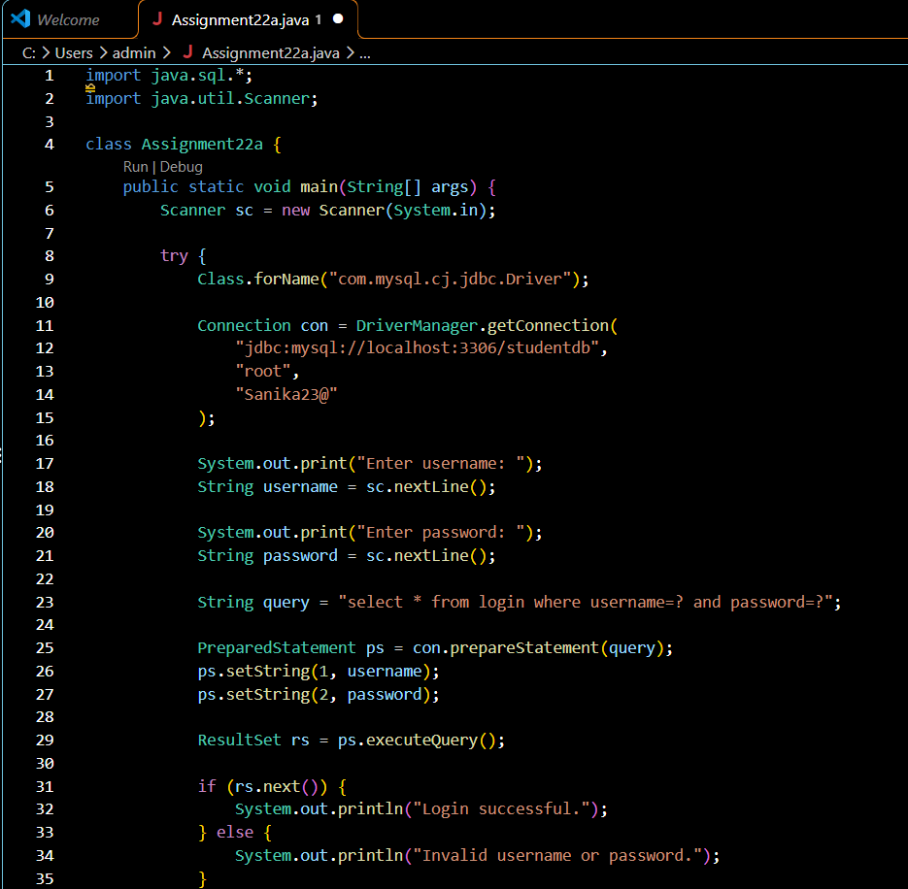
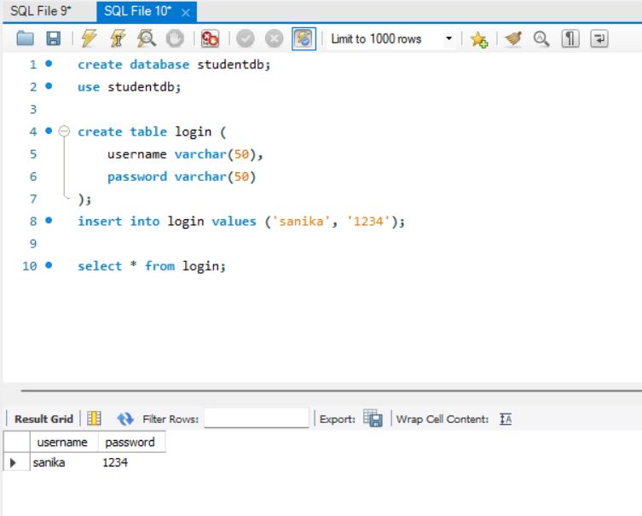
Output:
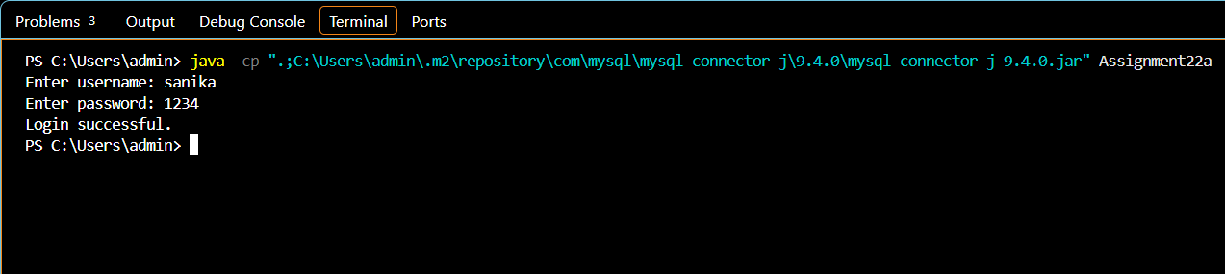

2. Create a Java application using PreparedStatement to authenticate hospital staff login (doctor/nurse/login ID and password). Display appropriate access messages based on authentication result.
Code:
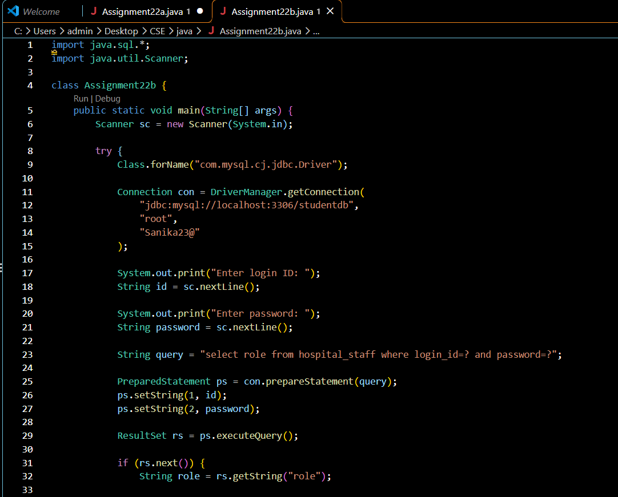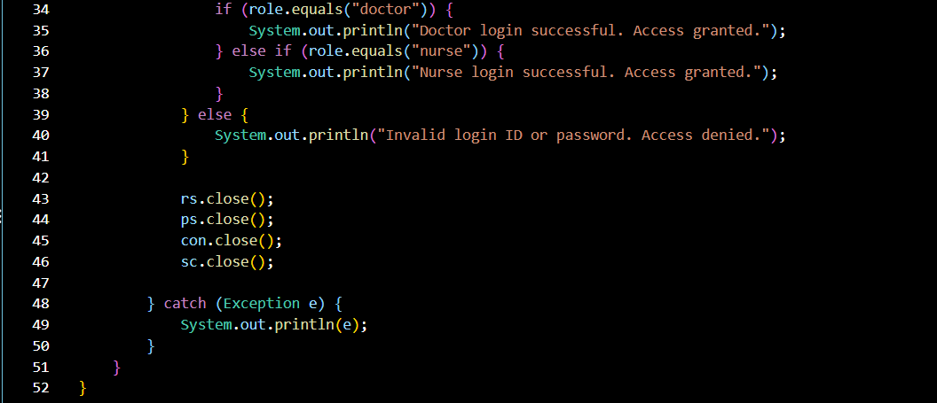
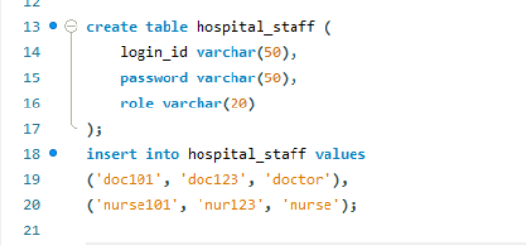

Output:

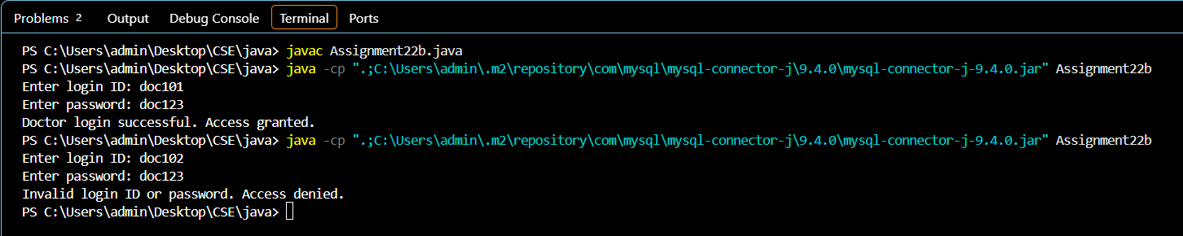

Conclusion
Thus, both exercises of Assignment 22 were successfully implemented using JDBC PreparedStatement and ResultSet. The programs verified login credentials, retrieved records from the database, and displayed appropriate messages for successful and unsuccessful authentication. This assignment helped in understanding secure SQL query execution and database record retrieval using JDBC.

